CAPSTONE PROJECT REPORT:
DEVELOPING INCIDENT RESPONSE PLAYBOOKS

BY: Suleiman Lukman

luqsule@gmail.com

Aim and Objectives

Aim

To develop a comprehensive incident response plan that enables the organization to effectively detect, contain, eradicate, and recover from phishing, ransomware, and Distributed Denial of Service (DDoS) attacks.

Objectives

To design a structured incident response playbook that supports timely identification and effective response to phishing, ransomware, and DDoS incidents.

To strengthen the organization’s cyber resilience by establishing standardized procedures that improve prevention, preparedness, and defense against these threats.

Methodology

Introduction

This incident response playbook was developed following reported cybersecurity incidents involving Techcrush21, a cloud service provider based in Abuja, Nigeria. The organization engaged a team of cybersecurity specialists to analyze the incidents and develop standardized response procedures aimed at preventing recurrence and minimizing operational, financial, and reputational impact.

Phishing Attack Scenario

Techcrush21 reported that several employees received suspicious email messages suspected to be phishing attempts. Recognizing the potential risk of credential compromise and unauthorized access, the organization requested the development of an incident response playbook to guide the identification, containment, and mitigation of phishing attacks, as well as to strengthen preventive controls and user awareness.



Ransomware Attack Scenario

Techcrush21 experienced a ransomware attack in which malicious actors encrypted critical organizational files and demanded a ransom of $300 of Bitcoin in exchange for the decryption keys. In response, the organization sought the development of an incident response playbook to support rapid containment, system recovery, data protection, and the prevention of future ransomware incidents.

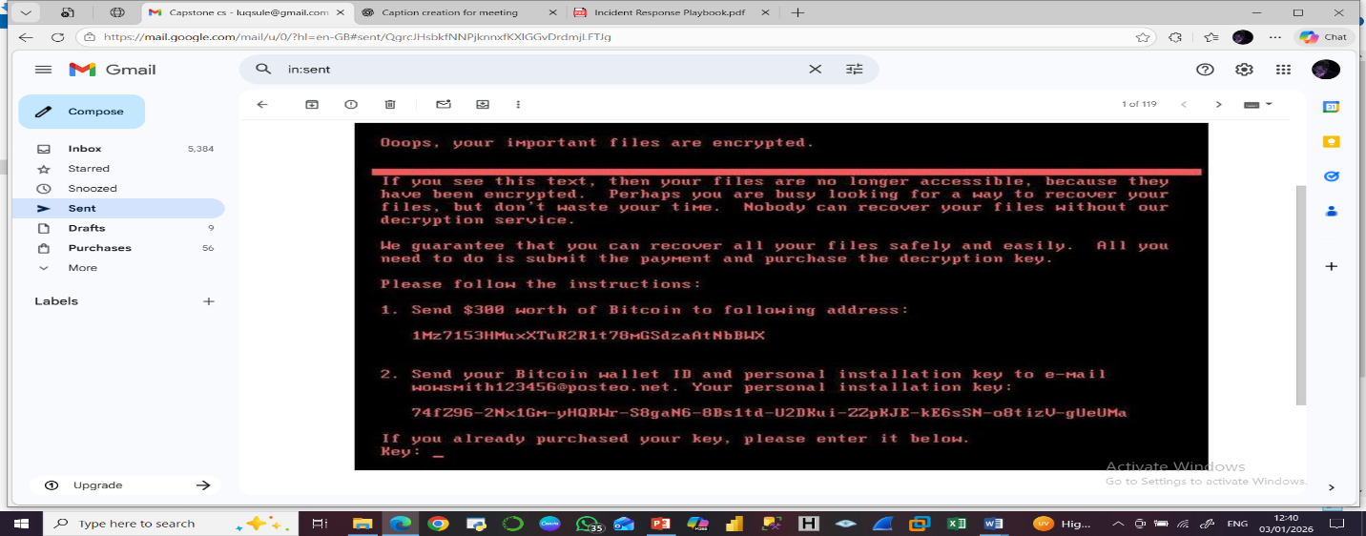

DDoS Attack Scenario
The organization also reported a large-scale Distributed Denial of Service (DDoS) attack, with traffic volumes reaching 1.47 terabits per second (Tbps). The attack disrupted website availability and prevented legitimate users from accessing services. To address this, Techcrush21 requested a comprehensive incident response playbook to guide detection, traffic mitigation, service restoration, and long-term resilience against high-volume DDoS attacks.

Triggers and Indicators
Phishing Attack
- Reports of suspicious or unsolicited emails from users
- Suspicious sender addresses or abnormal email return paths
- Emails containing unexpected links or attachments
Ransomware Attack
- Unexpected encryption of company files or systems
- Antivirus or endpoint security alerts indicating malicious activity
- Discovery of ransom notes demanding payment
DDoS Attack
- Repeated HTTP error alerts (e.g., 404 errors)
- Server unavailability or degraded performance
- Sudden and abnormal spikes in network traffic
Preparation Phase:
Establish the Cybersecurity Incident Response Team (CSIRT);The organization shall establish a core CSIRT responsible for handling cybersecurity incidents.
Core CSIRT Members may include:
- Security Analysts
- Network Administrator
- Incident Response Lead.
The core CSIRT should remain small to ensure confidentiality, efficiency, and rapid decision-making. Members may be activated frequently to investigate security events that may or may not escalate into full incidents.
Roles and Responsibilities (Core CSIRT):
- Incident Response Lead: Coordinates incident handling and escalation
- Security Analysts: Monitor, analyze, and investigate security alerts
- Network Administrator: Manages network controls, traffic filtering, and system availability
Extended CSIRT members are engaged when incidents escalate in severity or impact.
Extended CSIRT Members may include:
- Legal and Compliance Team
- Public Relations / Communications
- Executive Management
Roles and Responsibilities (Extended CSIRT):
- Legal/Compliance: Regulatory reporting and legal guidance
- Public Relations: Internal and external communication management
- Executive Leadership: Strategic decisions and resource authorization

Risk Assessment
Phishing Attacks
- Financial loss through fraud or credential theft
- Loss of sensitive or confidential data
Ransomware Attacks
- Financial loss due to ransom demands and downtime
- Loss or corruption of critical data
- Reputational damage and loss of customer trust
DDoS Attacks
- Server overload and degraded performance
- Service outages impacting availability
- Internet and network downtime

Identification Phase
During the identification phase, affected users and systems should be assessed using targeted questions.
Phishing Attack Identification
- Did you receive a suspicious or unexpected email?
- Did the email contain a link or file attachment?
- Did you click the link or download the attachment?
- Were you prompted to enter company credentials?
- Did the hyperlink redirect you to an unfamiliar website?
Ransomware Attack Identification
- Have your files been encrypted or become inaccessible?
- Was a ransom note displayed on your system?
- Were there alerts indicating malware, virus, or worm activity?
- Is there evidence of company data being advertised or sold on the dark web?
DDoS Attack Identification
- Are users experiencing network or internet downtime?
- Has there been a noticeable surge in inbound network traffic?
- Are legitimate users unable to access systems or services?

Detection Phase
Phishing Attacks
Detection of phishing incidents relies on continuous monitoring and analysis of email systems and security logs.
Key Detection Activities:
- Continuous monitoring of company email traffic and logs
- Identification of suspicious emails, sender addresses, and abnormal return paths
- Review of email subjects for social engineering indicators
- Inspection of embedded hyperlinks and file attachments
Tools:
- Splunk (SIEM): Centralized log collection and correlation
- VirusTotal: Analysis of URLs, attachments, and file hashes
- Have I Been Pwned: Detection of compromised credentials
- OSINT Framework: Threat intelligence gathering
- Censys and Shodan: Identification of exposed infrastructure
Ransomware Attacks
Ransomware detection focuses on identifying abnormal system behavior and malicious activity across endpoints and networks.
Key Detection Activities:
- Log monitoring and behavioral analysis
- Antivirus and endpoint detection alerts
- Scanning for unauthorized open ports
- IP address analysis and anomaly detection
- Monitoring dark web sources for leaked or advertised data
Tools:
- Splunk (SIEM)
- VirusTotal
- OSINT Framework
- Censys and Shodan
- Dark Web Monitoring Tools
- Anomaly Detection Systems

DDoS Attacks
- DDoS detection emphasizes traffic analysis and availability monitoring.
Key Detection Activities:
- Log monitoring and traffic analysis
- Network, port, and IP scanning
- Identification of abnormal traffic spikes and service disruptions
Tools:
- Splunk (SIEM)
- URLhaus
- OSINT Tools
- Shodan and Censys
Containment Phase
Phishing Attacks
- The goal of containment is to prevent further compromise and limit the spread of malicious activity.
Containment Actions:
- Isolate and disconnect affected user systems from the network
- Reset passwords for impacted user accounts, beginning with email accounts
- Revoke authentication tokens (authentication tokens are digital credentials used to verify user identity during active sessions; revocation invalidates all current sessions)
- Identify all affected systems and accounts
- Implement firewall and email filtering rules to block malicious domains, URLs, and message identifiers.
Ransomware Attacks
- Containment focuses on stopping the spread of encryption and preserving systems for investigation.
Containment Actions:
- Immediately disconnect all affected systems from the network
- Block or close suspicious ports and IP addresses
- Isolate infected systems without powering them off unless absolutely necessary
- Preserve malware samples and system states for forensic analysis
- Manage internal communications to prevent panic and misinformation
DDoS Attacks
- Containment aims to restore service availability and limit attack impact.
Containment Actions:
- Block malicious IP addresses and traffic sources
- Implement and adjust firewall rules and rate-limiting controls
- Coordinate with Internet Service Providers (ISPs) or DDoS mitigation services if required

Eradication Phase
Phishing Attacks
- Disable or remove compromised user accounts
- Apply required security patches and system updates
- Conduct comprehensive antivirus and endpoint scans
- Block all identified Indicators of Compromise (IoCs) such as malicious URLs, domains, and file hashes across email and endpoint security systems.
Ransomware Attacks
- Preserve encrypted systems, malware samples, and relevant backups
- Perform deep malware scans using enterprise-grade tools
- Reset all compromised credentials
- Conduct threat hunting to ensure no persistence mechanisms remain.
DDoS Attacks
- Remove malicious traffic rules once the attack subsides
- Patch vulnerable systems and services
- Review and strengthen network defenses

Recovery Phase
Phishing Attacks
- Restore affected data from verified backups
- Ensure all systems are securely backed up
- Gradually reconnect isolated systems and networks
- Monitor user accounts and email traffic for abnormal behavior.
Ransomware Attacks
- Restore systems and data from clean, offline backups
- Reconnect systems to the network in a controlled manner
- Monitor endpoints and network traffic for reinfection attempts
DDoS Attacks
- Restore full service availability
- Reconnect network services
- Continue monitoring traffic patterns to detect repeat attacks

Conclusion
This project emphasized that preparedness, standardized procedures, and continuous monitoring are essential for strengthening organizational cyber resilience. Implementing these incident response playbooks will enable organizations to reduce downtime, protect sensitive data, maintain service availability, and build long-term defenses against evolving cyber threats. The outcomes of this project reinforce the critical role of incident response planning in modern cybersecurity operations.
REFERENCES
• NIST. (2018). Computer Security Incident Handling Guide (SP 800-61 Rev. 2). National Institute of Standards and Technology.
— Primary reference for incident response phases (Preparation, Identification, Containment, Eradication, Recovery).
• ENISA. (2023). Incident Response: Best Practices and Guidelines. European Union Agency for Cybersecurity.
• MITRE ATT&CK®. (n.d.). Adversary Tactics, Techniques, and Procedures Framework. MITRE Corporation.
— Useful for understanding phishing, ransomware, and DDoS techniques.
• CISA. (2023). Ransomware Guide. Cybersecurity and Infrastructure Security Agency (CISA) & Multi-State ISAC.
• CISA. (2022). Understanding and Responding to Phishing Attacks. Cybersecurity and Infrastructure Security Agency.

